# Transit Method for Planet Detection

## Light Data C3

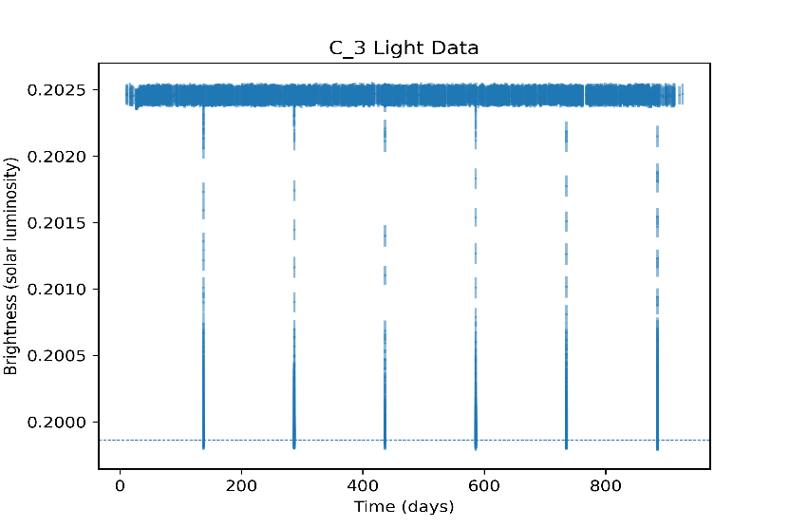Star Mass = 0.671 solar mass and Star Radius = 0.686 solar radii

Transit depth

Planet 1

The above graph (left) shows the light data for C3. From the graph it can be inferred that the transit data shows one planet orbiting its star. Taking an average of the distance between the minimums gives the approximate period of the planet. **The orbital period of C3 / Planet 1 is 149.47 days or 0.41 years.** From the period of the planet, its radius of orbit can be calculated as shown in sample calculations. **The radius of the orbit of C3/Planet 1 is 7.22 * 107 km or 0.48 AU.**

The graph on the right shows the curve for a single transit for C3/Planet 1. The depth of transit can be calculated as the difference between maximum and minimum brightness. The depth of the transit graph is 0.013. From this depth the radius of the planet can be calculated as shown in sample calculations. **The radius of planet C3/Planet 1 is 8.48 * REarth**.

The star for this system is a K type star with a surface temperature of around 4000 oC. The conservative estimate for the habitable zone for this system is between 0.1 to 0.3 AU. ({{Lillo-Box, 2022) Since the planet orbits at 0.48 AU, the odds of the planet having liquid water on its surface are very low. **The planet is most likely not habitable**. The small curve in the transit graph suggests that **the planet might have some atmosphere**. The size of the planet suggests that it is most likely a terrestrial planet since it is not big enough to trap gases in its gravity. The planet is most likely a **terrestrial super Earth**. From the spectroscopy data, the exact composition of the planet can be deduced. The line spectrum data can also give detailed information about the atmosphere of the planet.

|  |  |  |  |
| --- | --- | --- | --- |
| Light Curve and Planet | Orbital Period (years) | Planetary Radius (Earth Radii) | Planet Type |
| C3/Planet 1 | 0.41 | 8.48 | Saturn Sized rocky terrestrial |

## Light Data C2

Star Mass = 1.407 solar mass and Star Radius = 1.381 solar radii

## Sample Calculations

* **Radius of orbit from period**

$$P^{2}=KR^{3}$$

$$where, K=\frac{4π^{2}}{GM}$$

$with G being the gravitational constant and M being the mass of the star$**.**

For the planet of period 149.47 days around a star of mass 0.671 solar mass it’s radius is calculated as

$$R = \sqrt[3]{\frac{P^{2}GM}{4π^{2}}}$$

$$R=\sqrt[3]{\frac{{\left(149.47*24*60*60\right)}^{2}*6.67*{10}^{-11}*0.671*1.99*{10}^{30}}{4π^{2}}}$$

$R=7.22*{10}^{10}$ m

$R=7.22*{10}^{7}$ km

* **Radius of planet from depth in the transit graph**

$$Transit Depth={\left(\frac{R_{planet}}{R_{star}}\right)}^{2}$$

$$R_{planet}=R_{star}*\sqrt{Transit Depth}$$

For the transit depth of 0.01283656 and radius of star 0.686 solar radii

$$R_{planet}=0.686*695700*{10}^{3}*\sqrt{0.0128365}$$

$R_{planet}=54071626.26 m$ $$R_{planet}=54071.6 km$$

$$R_{planet}=8.4871*R_{earth}$$